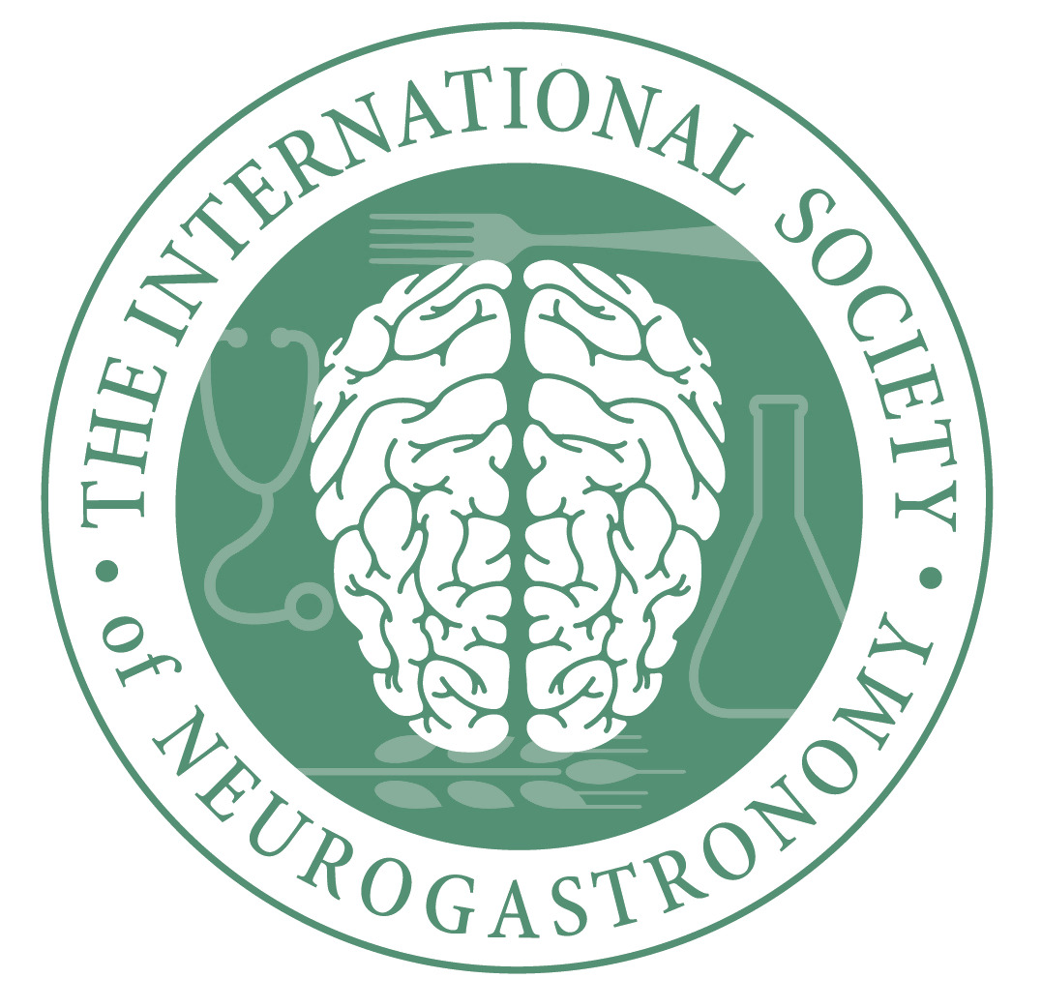

ISN 2020 Travel grants for Trainees and Persons from Underrepresented Groups

Funds from the National Institute on Deafness and Other Communication Disorders in the National Institutes of Health allow ISN to offer travel awards to citizens of the USA (or holders of green cards) for attending the annual ISN meeting. Applicants must be either:

- Underrepresented persons. Persons of recognized minority groups, disabled persons, and veterans are eligible.
- Trainees in a field of science or a profession with a relationship to neurogastronomy. Students, fellows, and postdoctoral trainees are eligible.

Procedures
- Review of applications will occur on a rolling basis even prior to the application deadline, which is March 16, 2020. After this date applications will be accepted only if funds remain available.
- Prepare a cover letter explaining your reason for requesting a travel award and the relevance of your training or profession to neurogastronomy. In this letter, provide estimates of the following costs: travel, lodging, registration. Trainees should also provide contact information for two persons capable of verifying trainee status. Include your surname in the file name.
- Prepare a resume or curriculum vita and include your surname in the file name.
- Submit these two files as attachments to: neurogastronomyabstracts@gmail.com

Review criteria and rules
Preference will be given to the presenting authors of posters, but others are also eligible. Only US citizens and holders of green cards are eligible. Awards may be used to cover travel only within North America, lodging, and meeting registration. Award amounts vary and in some cases may cover only part of the costs of attending the meeting. Travel awards may not be used for the ISN Dinner Workshop.

